Team Member Names:

Purdue Logins:

Section Number:

Team Number:

Submission Instructions:
- Rename this answer sheet to be Project_M1_Part2B_sss_tt.docx where sss is your section number (e.g., 001 for section 001) and tt is your team number (e.g., 07 for team 7).
- Submit this answer sheet along with the answer sheet for Part 1-2A to the M1 drop box on Bb prior to Class 23.

Notes:
- Only one(1) submission per team
- Only the last submission to the M1 Dropbox will be graded.
  - Make sure Part 1-2A and Part 2B Answer Sheets are all in the last submission.
  - Check to make sure the files can be accessed after uploading to Blackboard.
- After submission, distribute the submitted files to all team members. Ensure all members of the team have copies of the submitted files.

Learning Objective (LO): 21.02 Communicate ideas clearly and concisely
Evidence of Proficiency Requires:
- Purpose of communication is clear
- Processes are fully but concisely described
  - All steps are included
  - Assumptions are stated
  - Appropriate technical language is used
  - Clarifying images (e.g., sketches, graphs and/flow charts) are provided (as necessary)
- External research is accompanied by an in-text citation and full reference
Learning Objective (LO): 21.03 Evaluate model or algorithm development (e.g. ideas, work, functionality) using evidence-based rationales
Evidence of Proficiency Requires:
- Assumptions, claims, and critical decisions are clearly stated
- An appropriate source of evidence is used to support assumptions, claims, and critical decisions
- The evidence is clearly articulated
- External research is accompanied by an in-text citation and full reference

Part 2: Evaluation of Your Ideas
Section B: Noisy Data
Real experimental data always contains measurement noise, an example of which is shown in the figure below.

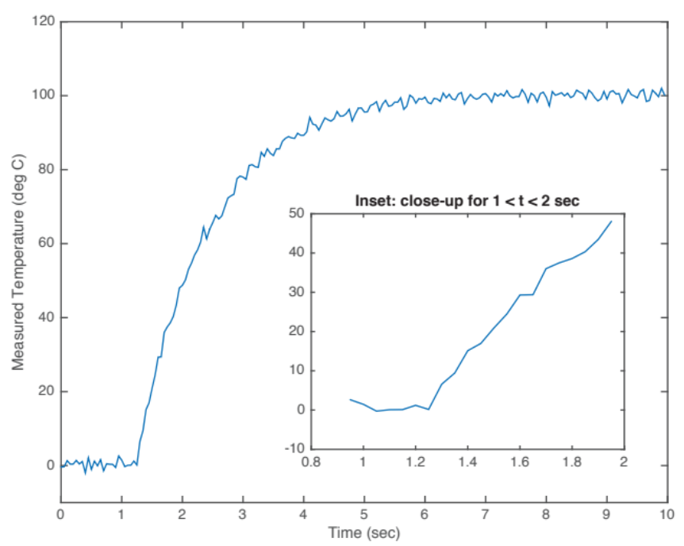

Experimental noise can come from many different sources, and it always makes parameter identification more challenging. In this part of the assignment, you must re-evaluate your approaches from Part 2A in light of the measurement noise.

For each of the approaches you described in Part 2A of Milestone 1:
- explain in a fewsentences how the approach might fail in the presence of noise. As appropriate include sketches to clarify your explanation.
- modify your approach to account for the presence of noise in the time history data. Use flowcharts and sketches to clarify your steps as necessary.
- re-assess the difficulty of coding this approach in MATLAB for analysis of noisy data and then justify in a few sentences your selected level of difficulty using evidence-based rationales (remember, your parameter identification must be fully automated). Again, your justifications must make explicit reference to MATLAB functions and coding techniques needed to translate your steps to operational code.

Approach #1A: Parameter t_{s} (Must be the same Approach#1A from Part 2A)
How could your approach fail in the presence of noise?

Modify your approach to account for noise.
Steps, in English, not code:
1.
2..
(add more steps as needed)

Expected difficulty for coding in MATLAB: ___ low ___ medium ___ high
What is your justification for this level of difficulty?

Approach #1B: Parameter t_{s} (Must be the same Approach#1B from Part 2A)
How could your approach fail in the presence of noise?

Modify your approach to account for noise.
Steps, in English, not code:
1.
2..
(add more steps as needed)

Expected difficulty for coding in MATLAB: ___ low ___ medium ___ high
What is your justification for this level of difficulty?

Approach #2A: Parameter τ (Must be the same Approach#2A from Part 2A)
How could your approach fail in the presence of noise?

Modify your approach to account for noise.
Steps, in English, not code:
1.
2..
(add more steps as needed)

Expected difficulty for coding in MATLAB: ___ low ___ medium ___ high
What is your justification for this level of difficulty?

Approach #2B: Parameter τ (Must be the same Approach#2B from Part 2A)
How could your approach fail in the presence of noise?

Modify your approach to account for noise.
Steps, in English, not code:
1.
2..
(add more steps as needed)

Expected difficulty for coding in MATLAB: ___ low ___ medium ___ high
What is your justification for this level of difficulty?

References Used in Evidence-Based Rationales

